ECG Arrhythmia Classification and Model Explainability via Permutation Feature Importance

Name | GUID | Name | GUID
Shradha Pahilkar | 3203266P | Sharique Hussain | 3256517H
Rohit Kalane | 3202398K | Manish Kumar | 3148978K
Salsabeel B.A. Alhamss

Introduction:
Cardiovascular diseases remain one of the major cause of mortality worldwide .One of the way to diagnose these are Electrocardiogram (ECG) which is considered as the gold standard as it is non-invasive method for monitoring the electrical activity of heart and detecting conditions like arrhythmias.An ECG records the heart’s electrical activity as a characteristic sequence of waves: the P-wave (atrial depolarisation), the QRS complex (ventricular depolarisation) and the T-wave (ventricular repolarisation). Cardiologists detect arrhythmias by comparing these waves with the normal cardiac cycle. Analysing the ECG OF 24 hours by human includes human errors, time consuming,and other errors also.Also analyzing this data and generating the annotated data is very hard.
This has motivated Machine learning to learn features of heartbeat and classify it automatically.
But using machine learning for this also has its own limitations:
- Unrealistic Performance estimates : A common evaluation protocol shuffles heartbeats from all patients and splits them randomly into training and test sets. Beats from the same patient share characteristics such as electrode placement, pre-existing conditions and medication, so beats of the same class from one patient look alike.Evaluating on patients the model has never seen gives a more honest estimate of how it would perform in practice .
- Lack of transparency: Many classifiers behave as black boxes, so clinicians cannot check whether a prediction rests on genuine electrophysiological features or on spurious artifacts such as noise, baseline wander or motion, which makes them reluctant to trust the model.
- Lack of Data: Annotating each second of each heart beat is not an easy task. It is very time consuming and requires dedicated people to do it.

This report address the first 2 problems of using MIT-BIH Arrhythmia Database.The database contain ambulatory ECG recordings from 47 subjects, digitised at 360 samples per second and annotated by cardiologists.Each beat is 275-point segment centered on its r-peak and standardised and is labelled with one of eight classes : [N,L,R,V,A,F,f,/].
These classes are heavily imbalanced .Most of the patients have normal heartbeats and belong to the class N.

Clear statement of predictive/exploratory question

The study asks two questions:
- (Predictive ) : How accurately the classifiers classify the eight beat types with 2 different types of data splittings ( beat holdout and patient holdout ).
- (Exploratory ) Which part of the heart beat( i.e P wave , ORS wave, T wave ) does the classification rely on.Which part adds more weight to the classification by using permutation feature importance.
We answer these questions by training both classifiers under each validation protocol, evaluating them with accuracy, precision,recall, F1 score and confusion matrix.
Also apply 5 fold method permutation feature importance to each model.

Details of the methods being used in the study i.e. main idea, important parameters to tune

Methods:

Dataset and signal pre-processing:

Data Source: The dataset used here is MIT-BIH Arrhythmia Database : Ambulatory ECG recordings from 47 subjects , digitised at 360 samples per second with 11 -bit resolution over 10 mv range on two channels.Ambulatory recordings capture intermittent, spontaneous arrhythmias that occur unpredictably. However, they also introduce real-world noise: motion artifacts, baseline drift (from respiration), and muscle tremors (electromyographic noise).
48 half-hour recordings were taken from 47 subjects (Records 201 and 202 are from the same patient). Approximately 60% were inpatients; 23 recordings were chosen at random, and 25 were selected intentionally because they contained clinically significant, uncommon arrhythmias (such as ventricular tachyarrhythmias, heart blocks, and pacemakers).
The recordings were annotated beat by beat by cardiologists.The signals were then read by python package ‘wfdb’( Waveform Database) which handles the beat files (.hea,.dat,.atr) and beats from both channels were extracted and stacked so that all beats in each record were obtained.
Two channels include:
- Upper channel : modified limb lead II obtained by placing the electrodes across the chest along the electrical axis of the heart . It produces tall, upright R peaks and distinctive P waves
- Lower channel : Electrodes are placed over specific intercostal spaces to view horizontal ventricular conduction.
Sampling Rate : The analog electrical voltage from the body is sampled 360 times every second. That equals 2.78 millisecond per sample.

Beat segmentation :
Each ECG wave has (P-Q-R-S-T) , the R peak is a tall, sharp upward spike .It is in the middle wave . It represents the peak electrical surge of ventricular depolarization.
It has the steepest slope and largest amplitude in the entire heartbeat.
The average human heart beats around 60- 80 times per minute in resting condition. So the average beat duration is 0.80 seconds that goes around ~764 ms. It is long enough to capture all phases of an individual cardiac cycle and also short enough to not overlap with the next p-wave.
Standard machine learning classifiers like SVM cannot process variable-length inputs, they need fixed dimensional matrices.
If beats were not aligned to the R-peak, Column 50 might represent a P-wave in one patient, a QRS-peak in another, and flat baseline in a third. The machine learning model would become completely confused.
By centering every beat on the R-peak, each column index jjj acquires a consistent physical meaning:
Time offset from R-peak=(j−137)×2.78 ms
After this the mathematical distance calculations compare the exact same physiological phase across thousands of beats.
Now we get the waves at different time frames like

Column indices | Time relative to R-peak | ECG feature
0 - ~100 | -380 ms to -100 ms | P- Wave and PR Segment
~100 - ~175 | -100 ms to +100ms | QRS Complex
~175 - 274 | +100 ms to +380ms | ST segment and T - Wave

Standarization:
All the beats are standardised at zero means and unit variance so that it eliminates the DC offset and low frequency baseline wander caused by patient’s breathing and chest expansion.
There are various factors like skin impedance and sweating (dry skin conducts electricity differently than moist skin) , anatomy and body composition ( a thin patient or athlete with an enlarged heart will produce larger R peaks than elderly people.)
The class ID and patient record numbers were appended at the end of each beat so that patient origins never become misaligned from their corresponding signals during shuffling or sorting.
So each row has 275 signal values+ 1 class ID +1 patient ID .

Class selection and encoding:
Only the original 8 annotation classes were kept , all other annotations were removed and encoded the classes to numbers from 1-8.

Annotations | Beat Type | Class ID
N | Normal | 1
L | Left bundle branch block | 2
R | Right bundle branch block | 3
V | Premature ventricular contraction | 4
A | Atrial Premature beat | 5
F | Fusion of ventricular and normal beat | 6
f | Fusion of paced and normal beat | 7
/ | Paced beat | 8

As the data was imbalanced,
Normal beats ( N ) has ~114368 samples (90% of data)
Fusion beats (F) has ~ 873 samples (<0.7 % of all data)
Imbalance ratio - over 136:1
Such model would achieve a high 90+ % accuracy , but suffer sensitivity to PVCs or Fusion beats
Instead of standard naive balancing we use down sampling majority and upsampling minority.
It ensures every class is equally present in the data forcing decision boundaries to give equal weight to every pathology. The training data were resampled but the test data was never resampled.
The reasons why test data was never sampled:
- If we resample the entire dataset before splitting , identical bootstraps duplicates of rare minority beats would end up in both training set as well as the testing set. The model will then simply memorize the duplicate test beats present in the training data and overfit the model.
- Keeping the test set untampered evaluates how the model will perform in the real world, where it must successfully detect rare pathological spikes without raising false alarms on millions of normal beats.

Validation Protocol :
In machine learning, the model assumes that training data is independent and identically distributed.
But in healthcare cases such as ECG, the heartbeats of the same persons are a lot dependent . A person’s heartbeat shares identical electrical properties,anatomical structure,electrode distance. So the way we partition this data determines the output of the model.
Here we have chosen 2 methods:

- Beat Holdout (Intra patient split) :
All the heartbeats from 48 records are pooled in a single csv and randomly shuffled.
These randomly shuffled records are then split 75% for training and 25% for testing.
When 75% of patients 101s are actually in the training set and 25 % in the testing set . The classifier does not need to learn the universal medical definition of the disease .It just memorized the signature of patient 101.
During testing it recognized the exact waveform shape from training affecting the accuracy. If deployed in a hospital on a new patient, this model often fails catastrophically because it never learned generalizable pathology, it learned patient memorization .

- Patient Holdout (Inter-Patient split) :
The dataset is split strictly based on the patient ID.
43 patients from the training set (resampled to balance the classes)
5 specific patients ( 104, 113,119,208,210) are locked for testing. Patient-Holdout evaluates true out-of-sample generalization across differing human anatomies, lead placements, and ages.
But here the held out patients contain o L,R,A beats so these classes cannot be assessed on the test set.

Classifications Methods:

We used two classifiers with different learning principles to make sure that the permutation analysis can show whether the results depend on the model or not. They both took the 275-point standardised beat as input and predicted one of the eight class IDs. Both were trained on the balanced (resampled) training data and evaluated on the original untouched test set under both validation protocols. Training on the full resampled set would have taken a lot of computational resources so instead each model was fitted on a stratified random sample of 8000 beats from it (about 1000 per class, seed 42). But the evaluation always used the full test set.

Support Vector Machine (SVM)
An SVM looks for the boundary that separates the classes with the widest possible margin. Only the beats closest to that boundary are called support vectors and they define it. A straight line is rarely enough for ECG shapes and structures thus we used the RBF kernel, K(x, x’) = exp(-y||x-x||²), You can think of it as a similarity score measure i.e. two beats with almost the same shape give a value close to 1, and the score drops towards 0 as the shapes diverge. Basically, it lets the SVM draw curved boundaries around the classes i.e. non-linear class boundaries. Since every beat is centered on its R-peak, each column has a consistent physiological meaning, so the distances compare the same cardiac phase across patients. The drawback is that the kernel depends on the exact values, so it can be thrown off by the patient-specific difference in beat shapes. Since we have eight classes, scikit-learn’s SVC trains one small SVM for every pair of classes ((8 x 7) / 2 = 28 in total) and the final class is chosen by voting.

Two hyperparameters matter most:

- C (regularisation): sets how much the model is punished for misclassifying training beats. A small C gives a smoother boundary that tolerates misclassified beats, while a large C fits the training beats very tightly and may end up memorising patient-specific shapes. We used C = 10.
- Gamma (kernel width): controls how far the influence of one beat reaches. A large gamma gives very local, irregular boundaries and a small gamma gives smooth linear ones. We used gamma = “scale”, which works as y = 1/ (n_features x Var(X)). For our standardised beats this comes out roughly at 1/275 i.e. 0.0036.

Random Forest (RF)
A random forest is a collection of decision trees that vote on the answer. Each tree is trained on a random bootstrap sample of the training beats and at every split it is only allowed to look at a random subset of 275 time points. This keeps the trees from all being copies of each other and averaging many different trees gives a more stable prediction than any single tree. Unlike the distance based boundary of the SVM, trees make decisions by splitting out on one time point at a time using a threshold, rather than comparing whole beats by distance. This difference is why it makes the comparison of their permutation importance interesting.

The main hyperparameters are:

- n_estimators: the number of trees. More trees give a steadier vote but take high computational cost. We used 150.
- max_depth: maximum depth a tree can grow. Deeper trees capture more details but overfit more easily. We used 15.
- Max_features: how many time points a tree can consider at each split. We used the default ‘sqrt’, which is about 16 out of 275.

Everything else was left as scikit-learn defaults (Gini creation, bootstrap sampling, min_samples_split = 2, min_samples_leaf = 1) and random_state = 42 so the results can be reproduced easily.

Hyperparameter settings

Model | Parameter | Classification Experiments | PFI Experiments
SVM | kernel | RBF | RBF
SVM | C | 10 | 10
SVM | gamma | ‘scale’ (≈ 0.0036) | ‘scale’ (default)
RF | n_estimators | 150 | 100
RF | max_depth | 15 | 12
RF | max_features | ‘sqrt’ (default ≈ 16) | ‘sqrt’ (default ≈ 16)
Both | random_state | 42 | 42
Both | Training subsample (stratified) | 8000 beats | 3000 beats

The settings used for the permutation feature importance (PFI) runs are a bit lighter than the ones used for the main classification. Within PFI, the model has to be refitted in each of the five folds and then predictions are repeated for all 11 slices. So we used a smaller stratified subsample of 3000 beats and cut the Random Forest down to 100 trees with a depth of 12 to keep the runtime feasible. We did not run a hyperparameter search. The values were chosen manually and kept the same for both validation protocols. A properly tuned configuration (for example a grid search with patient-grouped cross validation) could change the exact scores.

Evaluation metrics:
Models were evaluated on the test set only with a common function reporting accuracy, precision, recall, F1-score and the confusion matrix. Precision, recall and F1 are reported per class and as macro averages, because accuracy alone is misleading when the test set is dominated by normal beats. Classes missing from the patient-holdout test set (L, R, A) were excluded from the averages and handled with explicit class labels and ‘zero_division=0’.

Permutation Feature Importance:
Permutation feature importance is used to find out which parts of a heartbeat a trained model depends on. The idea is to scramble one part of the input and see how much the predictions get worse. If performance drops a lot, the model was relying on that part, and if it barely changes, the part matters little.
Each beat has 275 time points which is too many to interpret one by one. We group them into 11 non overlapping slices of 25 samples ( 69.4 ms ) each and treat each slice as a single feature.
Slice 1 covers samples 0-14
Slice 11 covers samples 250 - 274
Because R peak sits in the center of each beat, slice 6 (125-149) contains it.
Working with slices helps us link the results to p-wave , the ORS complex and the T-Wave and also keeps it computable.
Procedure :
1. Split the data into K = 5 folds, stratified on the beat class.
2. For each fold $k$, fit a new model on the other four folds and predict on the held-out fold to obtain the baseline predictions.
3. For each slice $j = 1, \dots, 11$, copy the held-out beats and randomly shuffle the 25 time points inside slice $j$, independently for each beat. Predict again with the same fitted model. The model is not refitted for each slice.
4. For each beat $i$, the importance of slice $j$ is the change in error:
$M_{ij}=1\left[{\hat{y}}_{i}^{(j)}≠y_{i}\right]-1\left[{\hat{y}}_{i}≠y_{i}\right]$
where ${\hat{y}}_{i}$ is the original prediction and ${\hat{y}}_{i}^{(j)}$ is the prediction with slice $j$ shuffled.
5. Average $M_{ij}$ over all beats and all folds to obtain one score per slice. Scores can be read as the increase in misclassification rate caused by shuffling that slice.

We measured error as a simple 0/1 misclassification rather than the squared error in the original formulation.
The class labels are categories, so squared error on the integer IDs would not mean anything, because class 8 is not “further” from class 1 than class 2 is.
With one-hot labels, the squared error of a wrong prediction is always 2 and of a correct one is 0, so the 0/1 error carries the same information.
Shuffling inside a slice was chosen over setting it to zero or to its mean, because shuffling keeps the amplitude values but destroys the shape of the wave. The model therefore loses the information in the local morphology without being shown an artificial flat segment.

Results / Metrics

The diagnostic classification performance of support vector machine and random first was evaluated across both beat hold-out and patient hold-out validation protocols on unseen dataset.

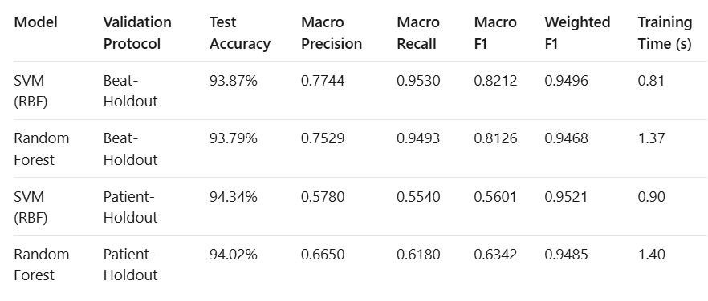

Table 1. Test performance of the SVM and Random Forest classifiers under the beat-holdout and patient-holdout validation protocols.

From the above given metrics :
- Accuracy is higher for Patient holdout (94.3 %) .This looks like the contrary what is stated above but the macro F1 tells the real story.
- Macro recall drops from 0.95 to 0.55 and macro f1 drops from 0.82 to 0.56 for SVM
- Accuracy is highly dominated by the normal beats (N) class
- Majority Class Dominance: The five held-out patient records (104, 113, 119, 208, 210) comprise 14,482 test beats, of which over 82% belong strictly to Normal sinus rhythm (64.7%) and Paced beats (17.3%). Both classifiers achieve near-perfect classification (>98%) on these distinct, high-voltage morphologies. Because overall accuracy is sample-weighted, high concordance on these dominant classes masks diagnostic failure on other rhythms
- A critical methodological consideration in patient-level cross-validation is the definition of the macro-average denominator. In our implementation, scikit-learn metrics were parameterized with zero_division=0 and explicit class labels. Because classes L, R, and A have zero ground-truth support (N=0N=0N=0) in the held-out patient cohort, assigning an automatic 0.0 score across an 8-class denominator imposes an artificial penalty for diseases not clinically present in the test cohort. Conversely, evaluating macro averages across the 5 actively present classes (N, V, F, f, /) isolates true cross-subject generalization on observed pathologies.

Confusion Matrix :
The 8 X 8 confusion matrices below display normalized true-positive rates(recall) along the main diagonals and reveal specific misclassification pathways across all eighth arrhythmia classes.
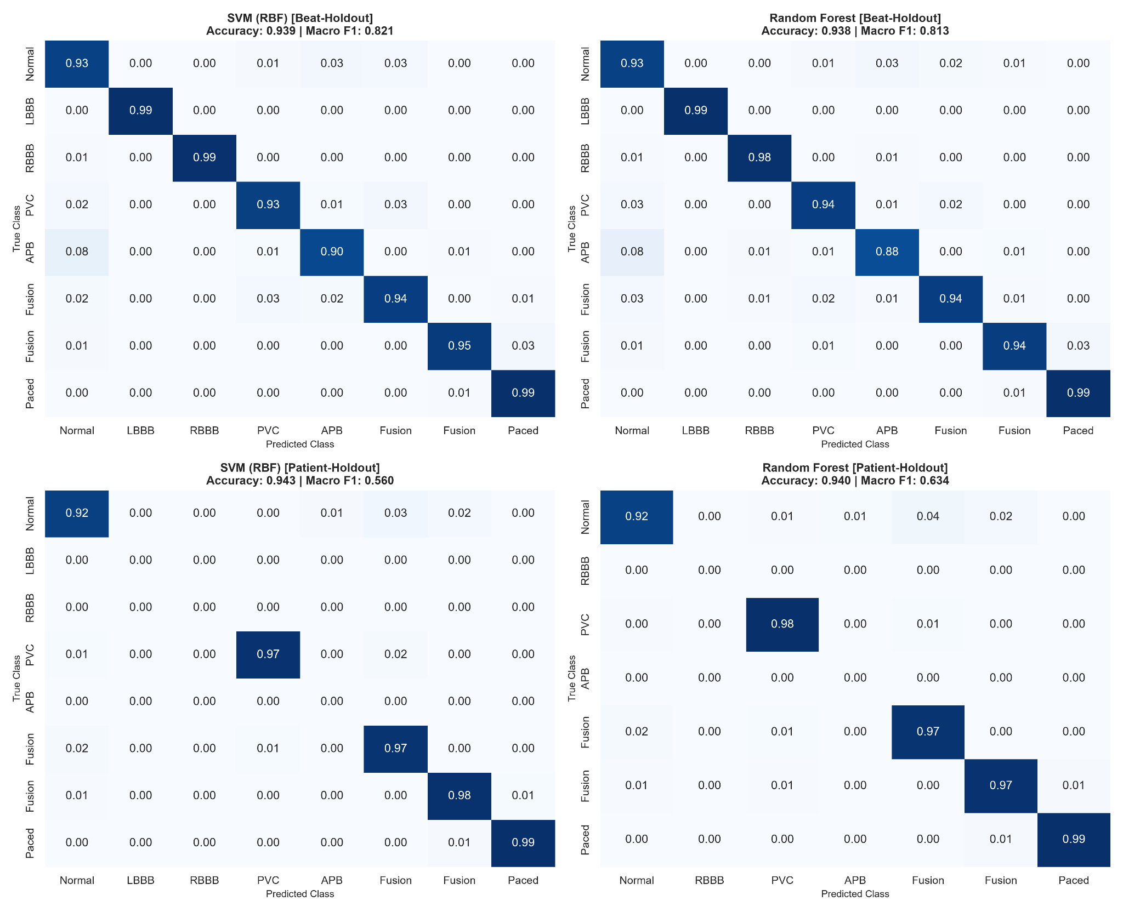

Top Row (Beat-Holdout):
Both SVM (left) and Random Forest (right) display strong diagonal dominance across all 8 classes (>90%>90\%>90% recall on most categories), demonstrating high sensitivity when beats from all patients are represented in both partitions.

Bottom Row (Patient-Holdout):
Demonstrates the effect of unseen patient morphologies. While Normal (N), PVC (V), and Paced (/) beats retain high diagonal recall (>96%>96\%>96%), classes L, R, and A have zero test support in the held-out patients (104, 113, 119, 208, 210), and rare fusion beats suffer cross-class leakage into PVCs.

Time Slice Permutation Feature Importance ( PFI)

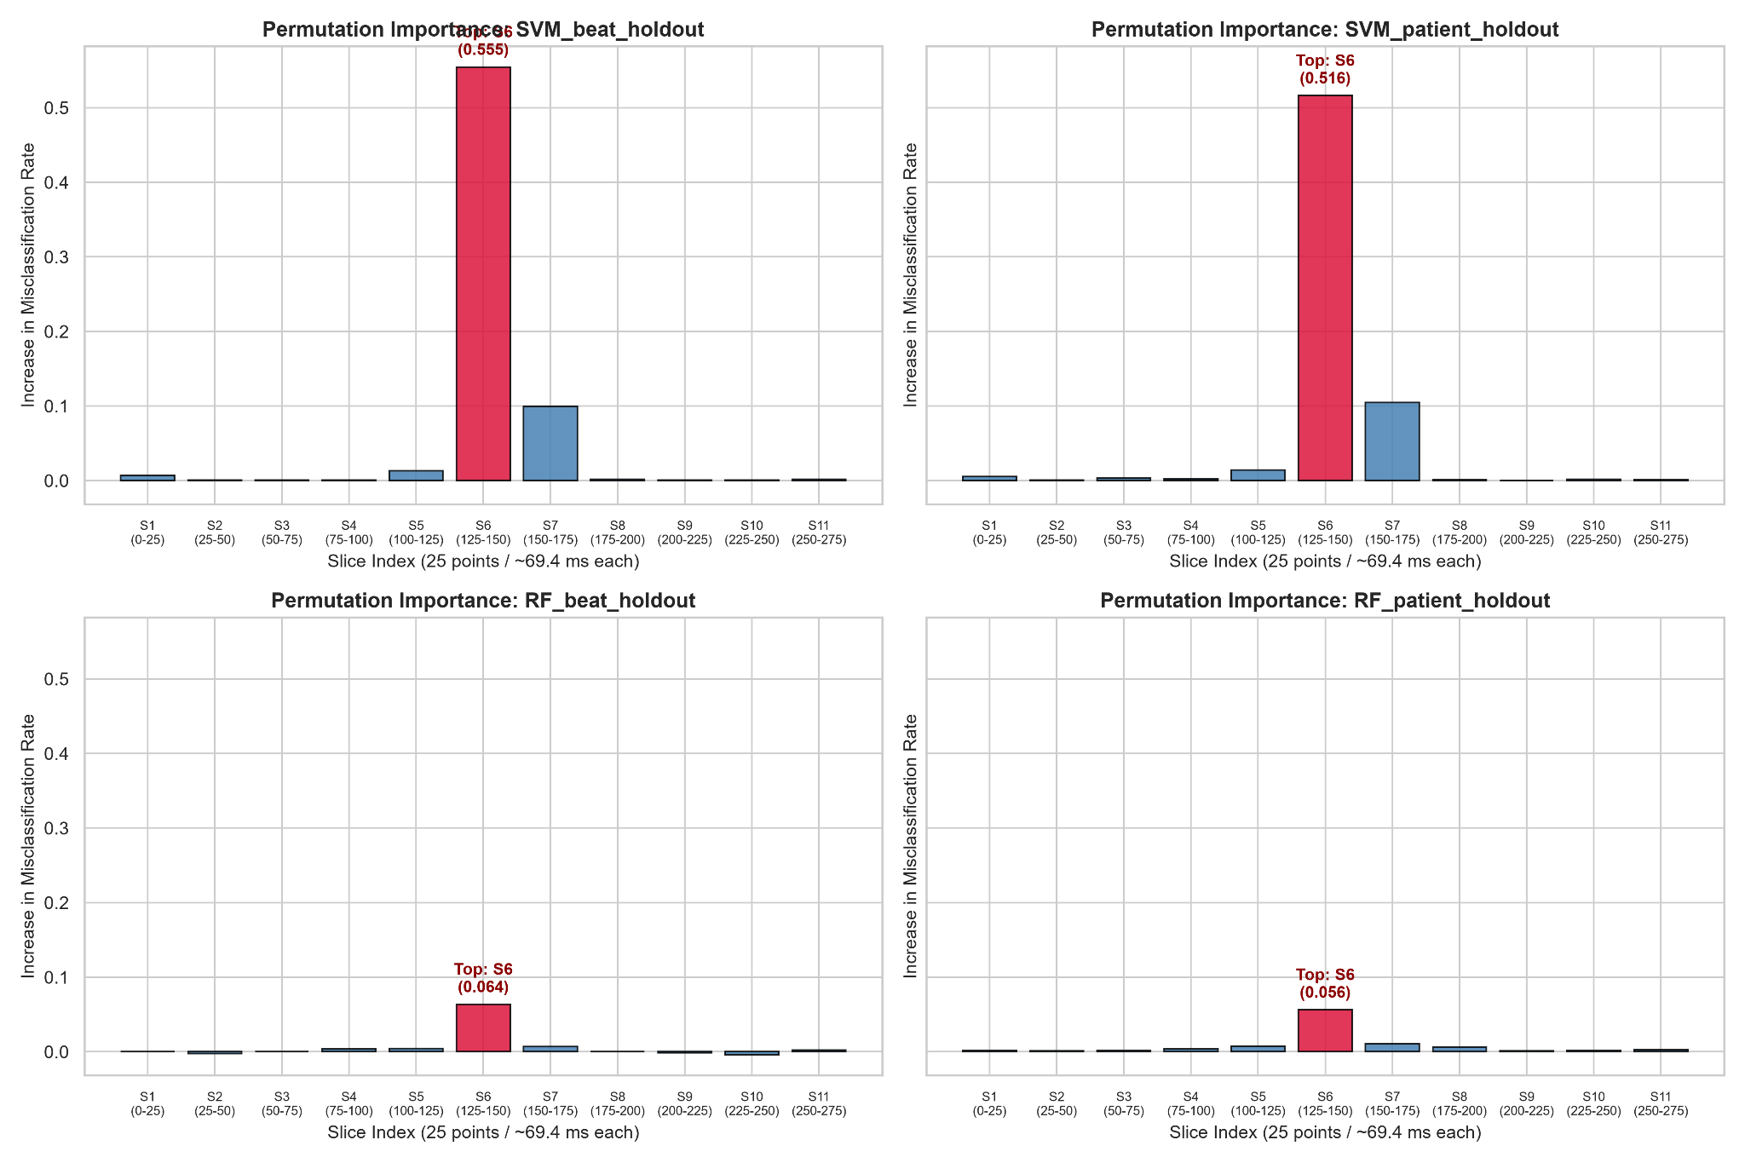

Overwhelming QRS Dominance: In all four configurations, Slice 6 (samples 125–149) is the undisputed peak predictor, followed immediately by Slice 7 (samples 150–174).

Classifier Architecture Contrast: SVM demonstrates an intense, localized dependency on Slice 6 (>50%>50\%>50% error increase), whereas Random Forest exhibits an ensemble-smoothed profile (~6% error increase) that distributes weight across adjacent features.

Physiological Waveform Overlays Shaded by Importance

These figures project the empirical PFI scores directly onto the raw ECG signal, highlighting the correspondence between algorithmic importance and clinical cardiac landmarks.

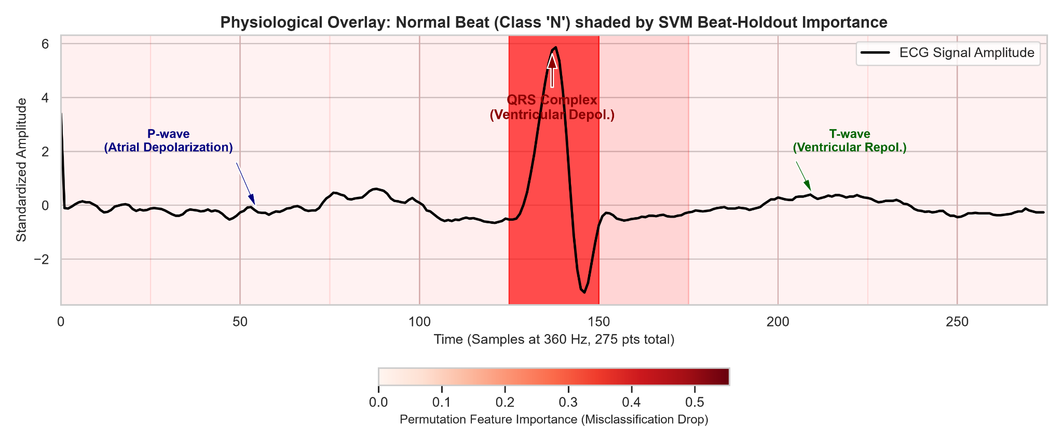
High importance ( red shading) tightly envelops the sharp, narrow R peaks.

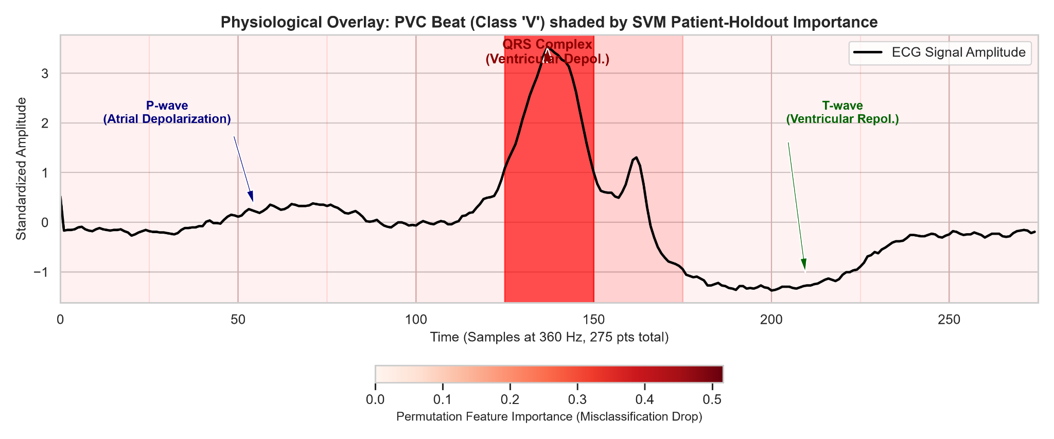
High importance spans the entire widened , bizarre ectopic QRS complex.

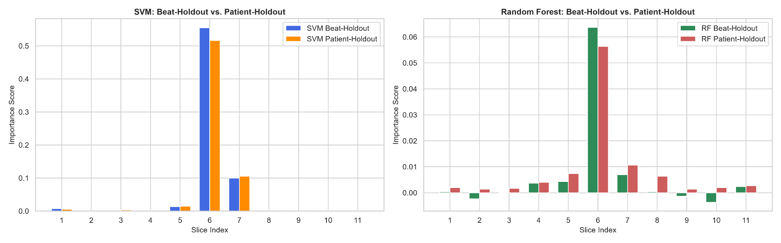
side by side comparison of PFI between SVM and RF
Model Agreement and Spearman Rank :
To evaluate whether the learned importance scores reflect genuine physiological signals rather than random artifacts of a particular classifier, we computed pairwise Spearman rank correlation coefficient across 11 dimensional importance vector.

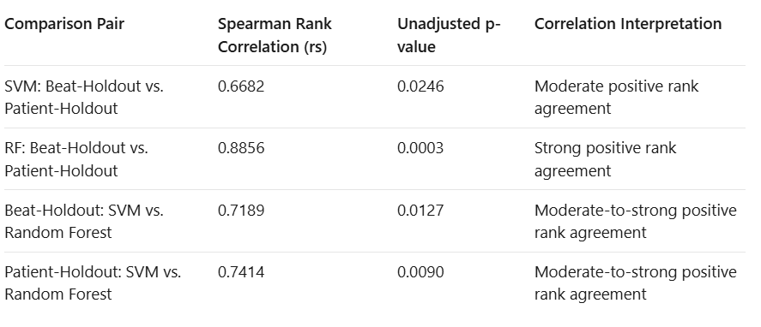

Model Concordance and Architectural Stability Across Validation Splits

Comparing the 11-slice Permutation Feature Importance profiles reveals critical insights into how each classifier navigates patient-level variation:

1. Random Forest Stability ($r_{s}=0.8856,p=0.0003$):
The Random Forest's temporal importance distribution remains remarkably consistent regardless of whether it is trained under Beat-Holdout or Patient-Holdout. Through ensemble bootstrap aggregation and random subspace selection, individual decision trees draw upon complementary morphological features (e.g., S-wave in Slice 7 and early ventricular deflection in Slice 5 alongside the central R-peak). Consequently, its learned decision rules are robust to out-of-distribution subject morphologies, explaining why RF achieves a superior Macro F1-score (0.6342 vs. 0.5601) on unseen patients.

2. SVM Morphological Sensitivity ($r_{s}=0.6682,p=0.0246$):
While the SVM consistently identifies Slice 6 as the primary locus of importance, its overall slice ranking shifts more noticeably between validation protocols. The non-linear RBF kernel maps the 275-dimensional ECG signal into an infinite-dimensional feature space where support vector margins are highly sensitive to exact point coordinates. As a result, inter-patient baseline variations and electrical axis shifts induce greater variation in the SVM's relative feature attributions.

3. Cross-Model Consensus ($r_{s}=0.7189$ and $r_{s}=0.7414$):
Under both validation protocols, the SVM and Random Forest display moderate-to-strong rank agreement ($r_{s}>0.71$). Those two fundamentally distinct learning algorithms. A margin-maximizing hyperplane kernel versus an ensemble of orthogonal axis-aligned decision trees converging on the same temporal prioritization confirms that QRS dominance is a genuine property of cardiac electrophysiology rather than an architectural artifact of a specific model.

Statistical Limitations of the Correlation Analysis

Several caveats must be acknowledged regarding the Spearman rank correlation analysis:
1. Small Sample Size ($N=11$ points):
Each rank correlation was computed across only 11 data points (one per temporal slice). With such small degrees of freedom ($df=9$), statistical power is restricted, and asymptotic $p$-values must be interpreted with caution. We therefore emphasize the magnitude of the rank correlation coefficients ($r_{s}$) as descriptive indicators of moderate-to-strong alignment rather than drawing strict binary conclusions from uncorrected significance thresholds.
2. Multiple Comparison Corrections:
Across the four statistical comparisons, applying a conservative family-wise Bonferroni correction ($α_{adj}=0.05/4=0.0125$) would cause the first comparison ($p=0.0246$) and third comparison ($p=0.0127$) to fall marginally outside the adjusted threshold.
3. Temporal Autocorrelation Across Adjacent Slices :
ECG time series inherently violate the assumption of statistical independence. Adjacent 25-sample slices share continuous physiological voltage trajectories and low-frequency baseline characteristics. This spatial and temporal autocorrelation effectively inflates the nominal degrees of freedom, further underscoring why reported $p$-values should be viewed as supplementary heuristics rather than definitive proof of independence.

Conclusion
This case study explored how effectively supervised machine learning algorithms, Support Vector Machines (SVM) and Random Forests (RF), can classify different types of cardiac arrhythmias using the MIT-BIH Arrhythmia Database. Alongside comparing model performance, the study examined how different validation strategies affect the reliability of results and used Time-Slice Permutation Feature Importance (PFI) to understand which parts of an ECG signal influence model predictions. The main focus was to address two important challenges in medical AI: ensuring that model performance reflects real-world generalisation and making model decisions easier to interpret.

1. Generalisation to Unseen Patients and the Risk of Data Leakage
Since heartbeats from the same patient can appear in both the training and testing sets, models may learn patient-specific ECG patterns rather than features that genuinely distinguish different arrhythmias. This can result in exceptionally high performance during testing without guaranteeing that the model will work equally well for new patients.Patient-Holdout validation provides a more realistic evaluation by ensuring that the model is tested on patients it has never encountered during training. Although the overall accuracy remained relatively high (94.34% for SVM and 94.02% for RF), these results did not tell the whole story.A closer look at the evaluation metrics revealed an important limitation. Normal and Paced beats accounted for more than 82% of the test samples, meaning that the models could achieve high accuracy while still struggling to identify less frequent arrhythmias. This was reflected in the Macro Recall, which dropped from 0.95 to 0.55, and the Macro F1-score, which decreased from 0.82 to 0.56 for SVM.These findings highlight why accuracy alone is not sufficient when evaluating medical classification systems. Macro Recall and Macro F1-score provide a more balanced view of performance across different classes, particularly when dealing with imbalanced medical datasets. More importantly, evaluating models on completely unseen patients is essential for understanding whether they can generalise beyond the individuals represented in their training data.

2. Understanding the ECG Features Behind Model Predictions
The Time-Slice Permutation Feature Importance analysis provided further insight into how the models made their predictions. Rather than treating the ECG signal as a collection of unrelated numerical values, the analysis helped identify which regions of the heartbeat contributed most to classification.The most significant finding was the strong importance of Slice 6 (samples 125–149), corresponding to approximately -33 to +36 ms around the R-peak. This region contributed the largest share of predictive importance across the models and validation settings, with the SVM showing an error increase of up to 55.5% when this region was disrupted. Slice 7, which covers the S-wave and early ST-junction, was also consistently important.This makes sense from a clinical perspective.The P-wave region (Slices 1–4), associated with atrial depolarisation, and the T-wave region (Slices 8–11), associated with ventricular repolarisation, showed smaller but non-zero contributions.Overall, the feature importance results suggest that the models relied primarily on clinically relevant regions of the ECG waveform rather than distributing their attention randomly across the signal.

3. Comparing Model Robustness and Clinical Potential
When comparing the two algorithms, Random Forest showed greater consistency across the different validation settings, achieving a Spearman rank correlation of 0.8856. It also achieved a higher Macro F1-score on unseen patients than SVM (0.6342 compared with 0.5601).One possible explanation is the way Random Forest combines predictions from multiple decision trees. Since individual trees can learn different patterns from the ECG waveform, the ensemble can make use of a wider range of temporal features. This may help it handle variations in ECG morphology between patients more effectively than the RBF-based SVM, which relies on its learned decision boundaries.Another interesting observation was the agreement between the two algorithms in their feature importance rankings. The cross-model Spearman correlations ranged from 0.72 to 0.74, indicating a reasonable level of agreement about which ECG regions were important

